Jam-Packed Soccer

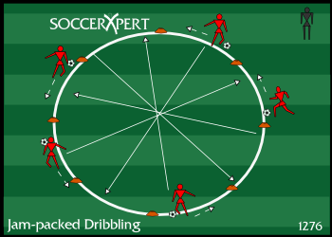
Drill Objective:
The Jam-Packed Soccer Dribbling Drill will give players confidence while dribbling through congested areas on the soccer field.

Drill Setup:
- Create a circle with disc cones that is approximately 20 yards in circumference.
- Make sure each player has a ball.
- Instruct the players to spread out around the outside of the circle.

Drill Instructions:
- Have the players begin the soccer drill by dribbling around the outside of the circle all in the same direction.
- The coach should inform the players to listen for specific queues and perform those actions once the coach shouts the command.
- These commands are:
  - JOG - players should dribble at a comfortable speed
  - FULL SPEED - players should dribble at their top speed
  - CUT - players should cut the ball in the other direction and travel in the other direction around the circle
  - CROSS - all players should cut across the grid avoiding contact with other players or other players balls.

Drill Coaching Points:
- Since all players are entering the center area at the same time, make sure players are looking ahead of them with their head up.
- Remind players to keep the ball close when entering the traffic area.
- Have players start playing with their arms up and out for balance and shielding.
- Instruct players to dribble with both feet and all parts of the foot.
- This drill is intended to be both helpful and fun, so make sure to HAVE FUN!

Drill Variations
- Think of other commands to add to the drill.

